Reactive gain control scheme for dancer positioning

Owen Lu

Electroimpact Inc.

owenl@electroimpact.com

*Abstract*—Previous a control scheme involving proportional gain selection to efficiently use the dancer stroke during multiple payout scenarios was developed. The main issue was the requirement of feedforward which complicates the system communication and introduces new failure modes. A new purely reactive method is discussed in this paper and its simulated performance compared to the Constant Position Gain (CPG) technique.

# Introduction

The goal of this new control technique is to generate similar performance of the CPG technique without the use of feedforward. Of course, feedback inherently adds delay to the system, since movement cannot be preempted. However, making key assumptions about the characteristics of the tow velocity profile allows very similar results to be obtained.

# Velocity profile characteristics

Key assumptions about the tow velocity profile allows reactive techniques to emulate performance of feedforward techniques. The assumptions are listed below.

1. Step inputs can only have a maximum amplitude of 2000in/min
2. Any speed above 2000in/min must be ramped to at some constant acceleration $a$

The reason that 2000in/min was selected is that adds are done at this speed. This means the feed roller is actuated while the drive is already at speed, causing a step input. Once material additions are down, the machine can go to full speed of course, requiring some acceleration $a$. Afterwards, cuts occur at roughly 1600in/min requiring clamp actuation and subsequent tow velocity drop to zero.

# Gain trajectory

Since the gain is no long constant in this, we consider the case of acceleration, and the subsequent effect on the gain if the tow velocity was known.

Recall that the gain can be calculated from steady state dancer position and velocity values (1).

|  |  |  |
| --- | --- | --- |
|  |  | () |

Taking the derivative assuming $x_{ss}=constant$

|  |  |  |
| --- | --- | --- |
|  | $$\frac{dK_{e}}{dt}=\frac{1}{x_{ss}}⋅\frac{dv}{dt}$$ | (2) |

If we assume that after material addition the machine accelerates at constant rate $a$, we obtain (3).

|  |  |  |
| --- | --- | --- |
|  | $$\frac{dK_{e}}{dt}=\frac{a}{x_{ss}}$$ | (3) |

This is easily solved via integration

|  |  |  |
| --- | --- | --- |
|  | $$K_{e}\left(t\right)=\frac{a}{x_{ss}}t+K_{e_{0}}$$ | (4) |

# Gain limits and saturation

Since the gain must have a lower limit to ensure performance during low speeds $K_{e_{0}}$ must be set to a lower safe gain limit. Previously 44.44rads-1 was used for the CPG method and will be used again.

|  |  |  |
| --- | --- | --- |
|  | $$K_{e_{0}}=44.44rads^{-1}$$ | (5) |

The maximum safe gain limit can also be set with the same equations used in developing the maximum for the CPG method. Thus, due to comparison we will use the same method.

|  |  |  |
| --- | --- | --- |
|  | $$K_{e_{m}}=141.6rads^{-1}$$ | (6) |

These are the constants that are used as saturation limits of the control signal.

# Conditional gain integration

The method to select gain comes from a simple algorithm described below.

* If the dancer position is larger than desired, turn up the gain
* If the dancer position is lower than desired, turn down the gain

The only question is then how much to change the gain in either scenario. This is easily calculated by using (7).

|  |  |  |
| --- | --- | --- |
|  | $$ΔK_{e}=\frac{a}{x_{ss}}Δt$$ | (7) |

# Anti integral wind-up

Problems occur if the current scheme is used even with the saturation limits. During start up, the integrator begins to build up and become largely negative. This causes a delay in the response to the ramp since the negative integral value must be compensated. A simple method to solve this is to use the back calculation solution to integral wind-up.

This is a standard technique and therefore will not be discussed in this paper. The one parameter to be varied is the back calculation constant $K_{bc}$. $K_{bc}$ effectively specifies how quickly the integral is reset from saturation. In this case faster is better, and a constant of $K_{bc}=100$ is used.

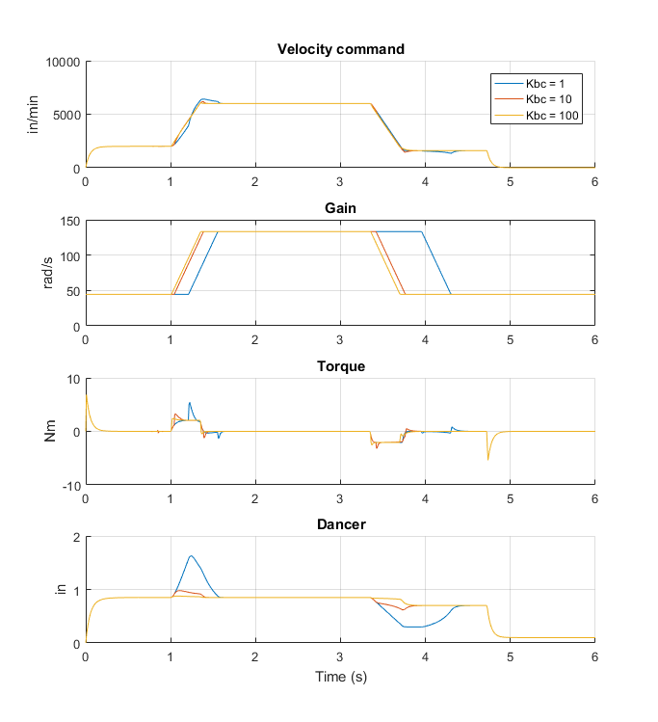

Figure 1 - Simulated results for $K_{bc}=(1,10,100)$

# Results

Comparing the Integrated Constant Position Gain (ICPG) method to the old CPG method, we see the results are very similar from Figure 2. Both methods used the exact same tow velocity profile and we can see the difference is very minimal.

# C:\Users\owenl\Documents\MATLAB\2tow\VS ICPG.bmp

Figure - CPG vs ICPG method performance

This is the ideal case where the slope $\frac{a}{x_{ss}}$ exactly matches the actual tow acceleration. It is also important to know the consequence of mismatched acceleration. In Figure 3 a simulation with ICPG was conducted with $a=\frac{1}{4}G$ ramp where the control scheme assumed that $a=\frac{1}{2}G$. We can see the rapid gain switching caused by switching over the dancer position conditional. However, the dancer performance improves and the torque spikes are very much below the peak torque limits.

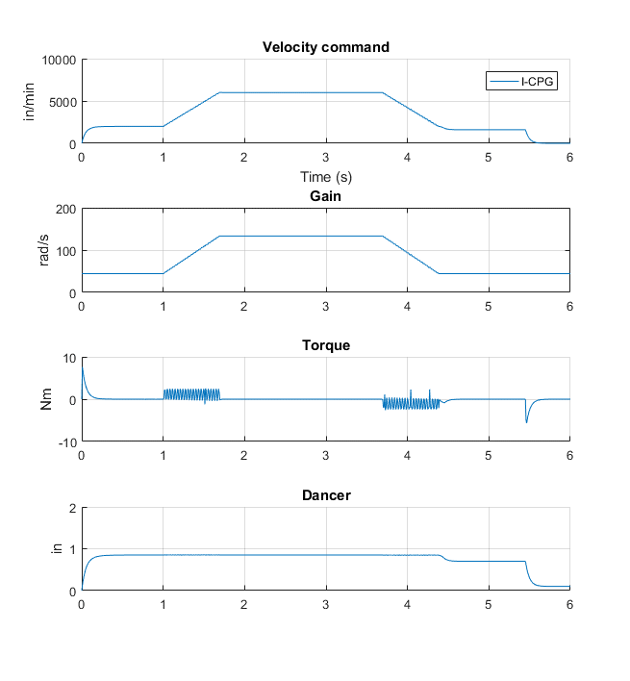

Figure - ICPG with mismatched acceleration

# Conclusion

The ICPG method seems to provide similar results to the CPG method without the complexity of setting up extra communications. This is a great advantage in the implementation sense, however, more computations done on the motor side will necessarily slow down control loop sample rates. Thus, in practice this method must be tested to ensure stability is maintain even at lower sample rates.